**Adding, Subtraction, & Multiplying Fractions**

**Unit 4**

**Homework Helper**

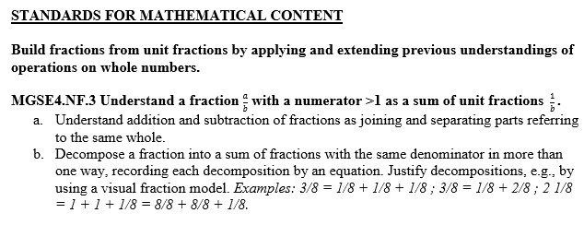

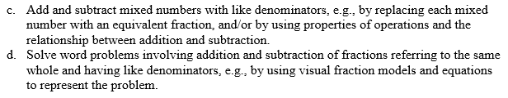

Decompose a Fraction

To decompose a fraction, you break up a fraction into the sum of the fraction. The area model below is divided into 5 equal parts, and 3 of those parts are shaded in. This fraction can be decomposed in two ways: 1/5 + 1/5 + 1/5 = 3/5 and 2/5 + 1/5 = 3/5.

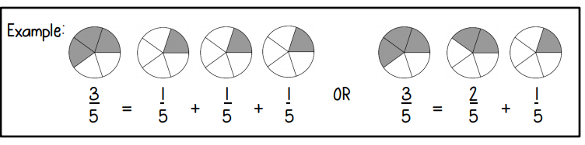

Add Parts of a Whole Using Models

When adding fractions with like denominators, their sum will have the same denominator. Just add the numerators. Simplify if needed.

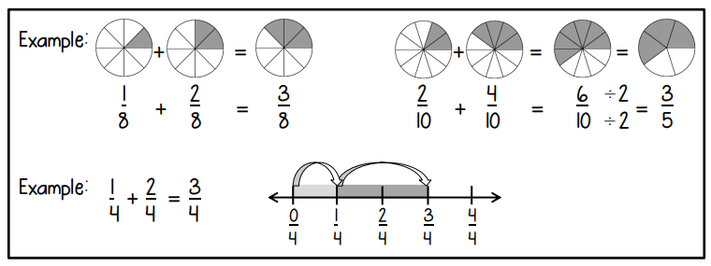

Add Parts of a Whole

When adding fractions with like denominators, their sum will have the same denominator. Just add the numerators.

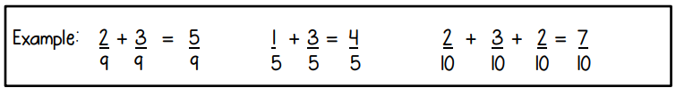

Subtract Parts of a Whole Using Models

When subtracting fractions with like denominators, the denominator will stay the same. Just subtract the numerators. Simplify if needed.

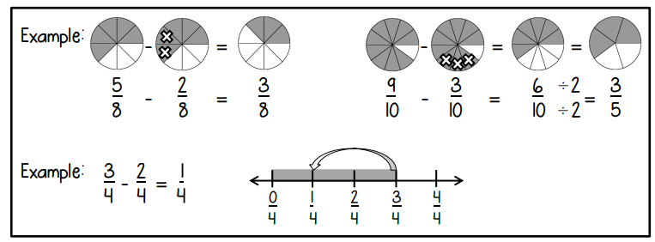

Improper Fractions

When solving the following problem, the numerator will be larger than the denominator. This is called an improper fraction.

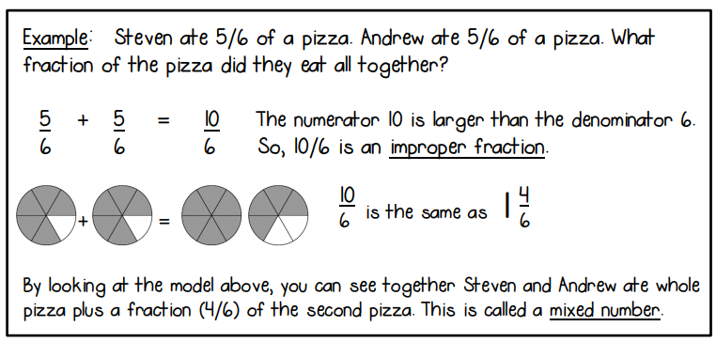

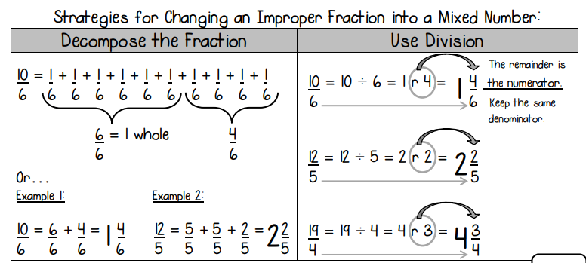

Mixed Numbers

Mixed numbers can also be renamed as improper fractions.

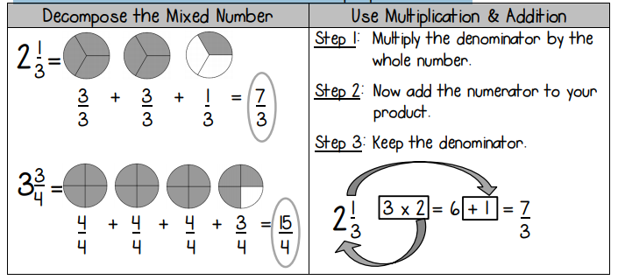

Add and Subtract Mixed Numbers

When adding or subtracting mixed numbers, add/ subtract the whole numbers first, then add/subtract the fraction parts.

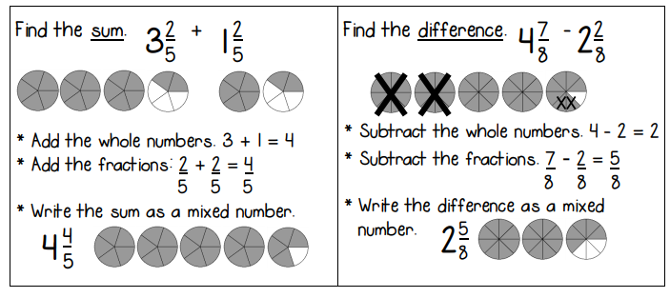

Renaming Mixed Numbers to Subtract

Sometimes when subtracting mixed numbers, the first fraction is smaller than the second fraction. When this happens, use one of the following strategies:

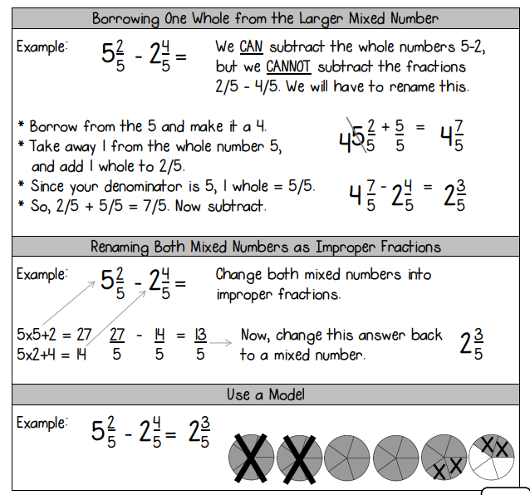

MGSE4.NF.4 Apply and extend previous understandings of multiplication to multiply a fraction by a whole number. a. Understand a fraction a/b as a multiple of 1/b. For example, use a visual fraction model to represent 5/4 as the product 5 × (1/4), recording the conclusion by the equation 5/4 = 5 × (1/4). b. Understand a multiple of a/b as a multiple of 1/b, and use this understanding to multiply a fraction by a whole number. c. Solve word problems involving multiplication of a fraction by a whole number, e.g., by using visual fraction models and equations to represent the problem

Relate Addition & Multiplication: Decompose Fractions

Remember, to decompose a fraction, you break up a fraction into the sum of the fraction. The area model below is divided into 5 equal parts, and 3 of those parts are shaded in.

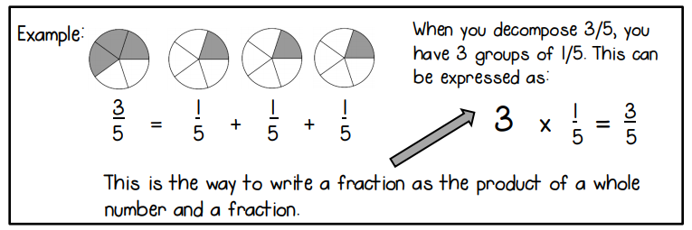

Multiples of Unit Fractions

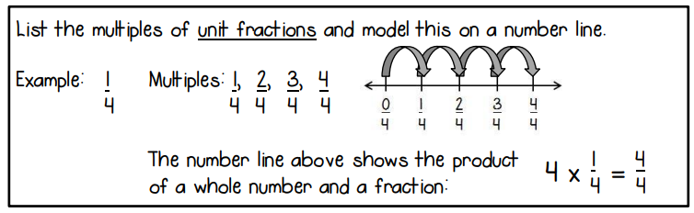

Multiples of Other Fractions

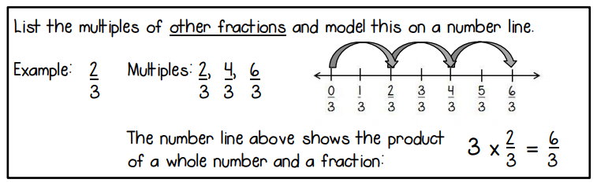

Use Models to Multiply Whole Numbers & Fractions

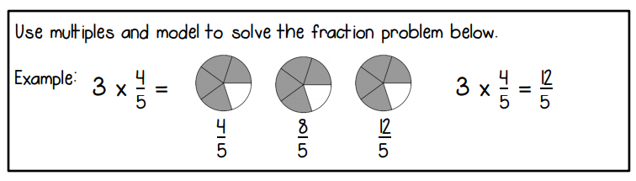

Multiply Whole Numbers & Fractions

1. Multiply the whole number by the numerator.
2. Keep the denominator the same.
3. Rewrite any improper fractions as whole or mixed numbers.

$$3 X\frac{4}{5}=\frac{12}{5}$$

$$\frac{12}{5}=\frac{5}{5}+\frac{5}{5}+\frac{2}{5}$$

$$\frac{12}{5}=2\frac{2}{5}$$